Data Formatting and Standardization
Given a dataset containing names in different formats such as john, JOHN, and
John, standardize all names into a consistent format.

AIM
To standardize names in a dataset by converting names with different capitalization formats, such as john, JOHN, and John, into one consistent format.

PROCEDURE
- Import the Pandas library.
- Create or load a dataset containing names.
- Identify inconsistent capitalization formats in the name column.
- Use the .str.title() function to convert each name into title case.
- Replace the original names with the standardized names.
- Display the updated dataset.
- Verify that all names follow a consistent format.

CODE:
import pandas as pd
data = {
'Name': ['john', 'JOHN', 'John', 'alice', 'ALICE', 'Bob']
}
df = pd.DataFrame(data)
print("Original Dataset:")
print(df)
df['Name'] = df['Name'].str.title()
print("\nStandardized Dataset:")
print(df)

OUTPUT:
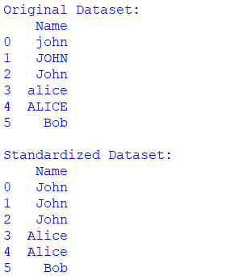

RESULT:
The names in the dataset were successfully standardized into a consistent format. For example, john, JOHN, and John were all converted to John, improving the consistency and quality of the dataset.

